MATLAB HOMEWORK 4
Exercise 5.1 Use PPLANE to plot the phase-portrait of (2). (To do this you will need to set the values in the x' and y' boxes in the setup window, leaving everything else the same). Click at some points on the diagram to see the solution curve through those points. Now try changing the values of x' and y' from -2 and 3 to other constant values, and examine how this changes the phase portrait. How can we change the values to make the arrows point in the opposite direction from the ones in the phase portrait for equation (2)?

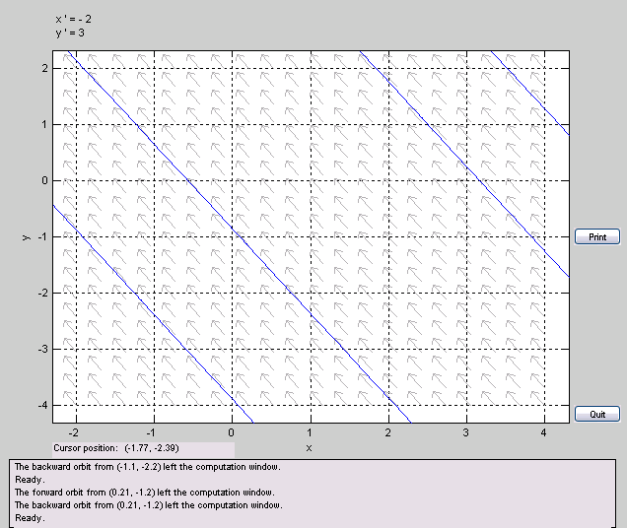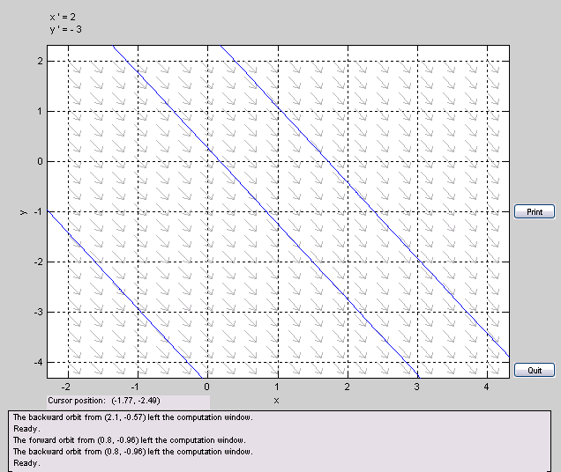

The portrait on the left shows x’= - 2; y’=3, while that on the left shows the portrait inverted at the “origin,” i.e. x’=2; y’= -3. To make the arrows point in the opposite direction, you merely reflect them across the “origin.”

Exercise 5.2 Set the minimum values for both x and y to -10, and the maximum values to 10. Plot the phase-portrait of (3). Click on some points on the diagram to see the solution curve through those points.
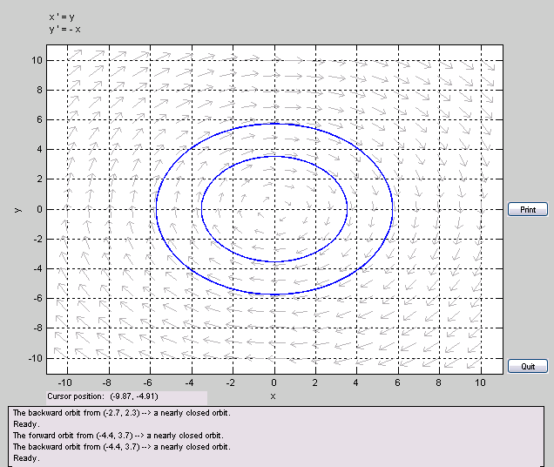

Exercise 5.3
(a) Plot the phase-portrait of (4) and some solution curves. Now choose Solutions -> Show Nullclines on the PPLANE display window. Include the nullclines in your graph.
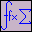(b) Calculate (by hand) the nullclines for the system (4), and identify them on the graph.
a) The nullclines are the pink and orange lines. The blue lines are some possible solutions. Note how this diagram makes for a nice company logo.
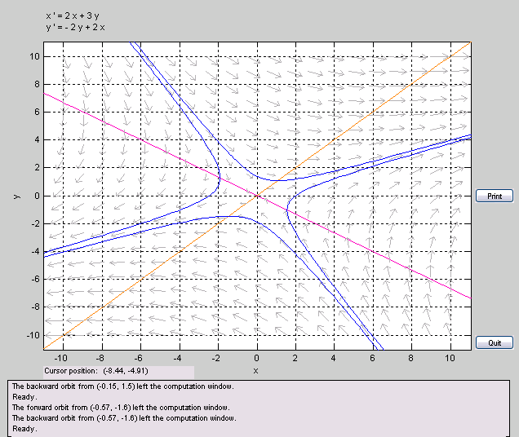
b) The nullclines are determined as follows:
f = x’ = 0 = 2x+3y → y = -2x/3 … this is the pink line (the line that looks like a left diagonal: \ )
g = y’ = 0 = -2y+2x → y = x … this is the orange line (the line that looks like a right diagonal: / )
Exercise 5.4 Using PPLANE, plot the phase portrait of the above linear system (5). Set the minimum and maximum values for x and y to -4 to 4. In the Parameters or expressions boxes enter a = 0.5. Click on a few points on the plane to see solution curves. | 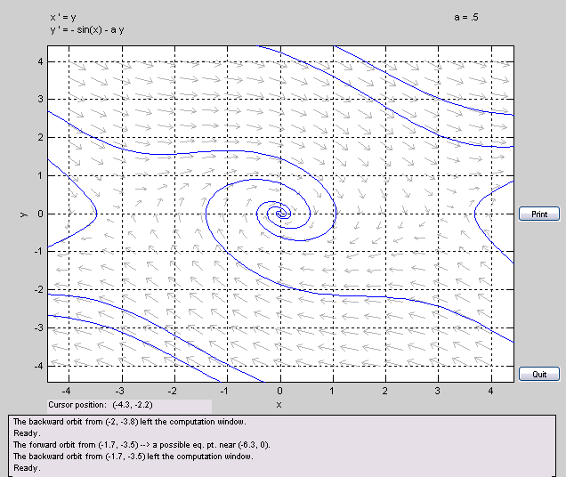

Exercise 5.5 (a) The point labeled A above, represents the initial state of the pendulum. Recall that the x-coordinate is the angle in radians relative to the vertical position, and that y is the angular velocity. What is the state of our pendulum when it starts swinging?
Since x=0 corresponds to the starting vertical position at equilibrium, x=1.5 < Pi/2 would be the position a slight bit before the horizontal. Since y(0)=0 = x’(0) , the pendulum starts from rest.
(b) At the point B, the value of y is 0 again, while the value of x is now negative. What has happened to the pendulum when it reaches this point?
This is the turning point on the other side of the starting vertical position at equilibrium. The pendulum has momentarily stopped at y=0=x’, and it will turn around. (The turning point is not symmetrical with respect to the starting point because of the damping.)
(c) Our curve next crosses the x-axis at the point C. Where is the pendulum now and how does this new position compare with the initial position A?
The pendulum is now on the right side of the starting vertical position at equilibrium. However, it is now closer to the equilibrium position than it was at point A. This is due to the dampening.
(d) The curve continues to spiral into the origin (this point is not labled). What state of the pendulum does this point represent?
The origin represents x=0,y=0=x’. This is where the pendulum stops forever, i.e., its stable equilibrium. Incidentally, it is also its starting position.
Exercise 5.6 Change the value of the parameter a in the Parameters or expressions boxes to a value of your choosing. Make plots for a range of values of a, including a = 0, a = 0.1, and a = 10. (Remember to click the Proceed button on the setup window each time you change a). How does the value of a affect the behavior of the solutions? Include graphs for three different values of a to demonstrate this. Why do you think a is called the damping constant? 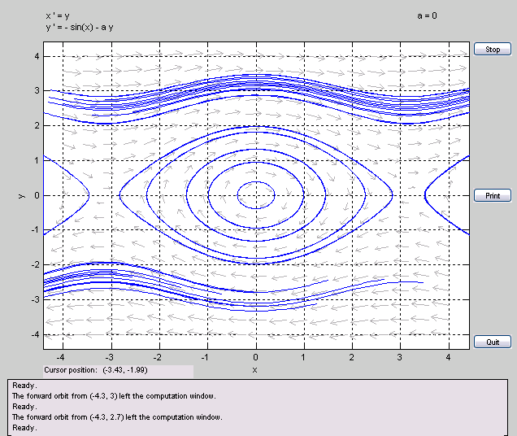 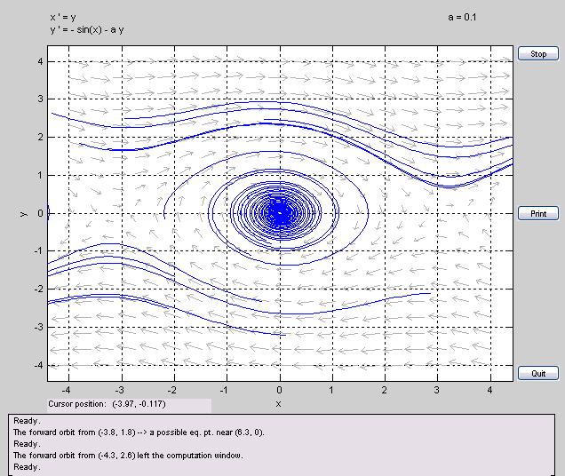 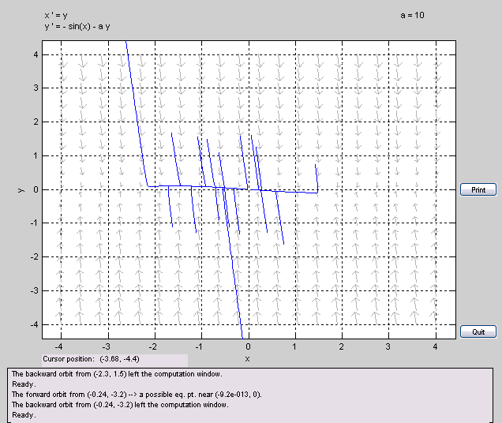
a is called the damping constant because the bigger it is the more damped the pendulum is. As shown from the 3 graphs of varying values of a, one can see that as a increase, the pendulum reaches stable equilibrium at (x,y)=(0,0) faster. Also, for the case a=0, where there is no damping, the pendulum exhibits symmetry in turning points.

Exercise 5.7 Set the value of a back to 0.5. Set the minimum x and y values to -20, and the maximum x and y values to 20. Click in a few places. Notice that the phase portrait repeats itself periodically. What is the length of the period? Why does this happen?

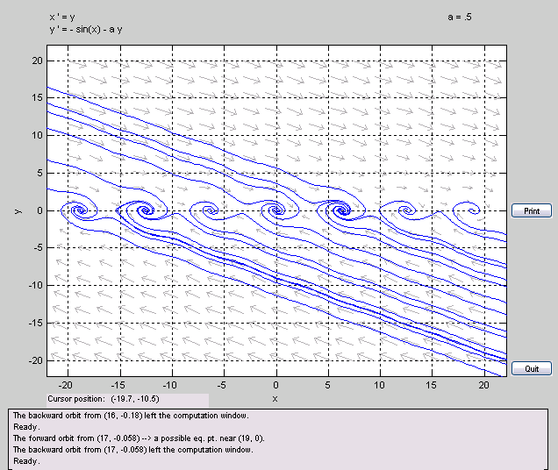
The phase portrait repeats itself periodically because of the sin(x) term. The length of the period can be seen from the locations of the stable equilibrium, and it appears to be 2Pi. This makes sense, since the stable equilibrium has infinite degeneracy: 0, 2Pi, 4Pi, 6Pi, as well as -2Pi, -4Pi, -6Pi, i.e., 2nPi, where n is an integer.
(Notice that if we live in a 4Pi-symmetry world instead of a 2Pi symmetry world, i.e, where
e^(i 2 Pi)= -1 instead of e^(i 2 Pi) = 1, having two stable equilibrium points would correspond to actual *distinct* and physically valid points.)

Exercise 5.8 Using the nullclines, find the stationary points of the system. (Notice that since the phase portrait is periodic, we will have infinitely many of them.)

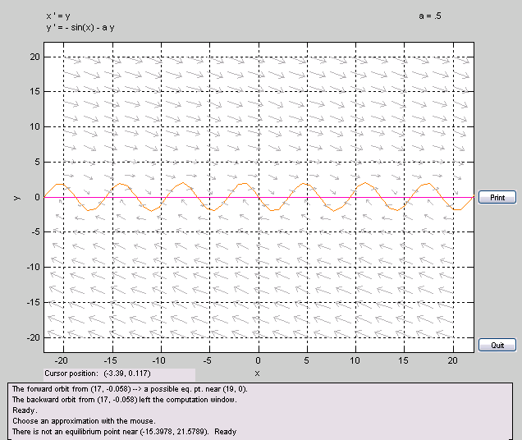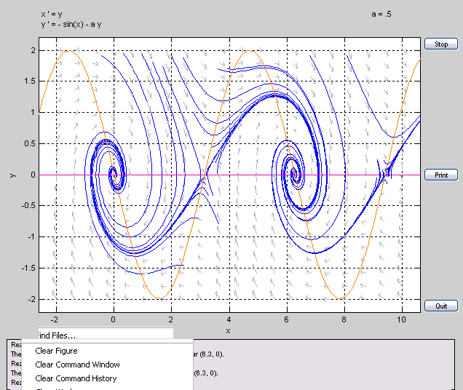
The stationary points of the system appear to be at (x,y) = {(0,0),(Pi,0), (2Pi,0),…}

Exercise 5.9 Which of the stationary points you found in the previous exercise are stable and which are unstable? Based on these values and the above discussion, what state of the pendulum do the set of unstable stationary points represent

The stationary points at x = n * PI , where n is an odd integer are unstable, since the solution curves diverge from these points. These points represent starting the pendulum on the very top, at an 180 degree angle according to its starting position at x = 2 n Pi. These points are unstable because although you can “balance” the pendulum by placing it “upside down” at an 180 degree angle from its starting point, a slight bit of hot air would upset it, and the gravitational potential (or whatever potential at work here) will pull it downwards.

